Create airport table.

hive> Create external table airports_savu (IATA String, Name String, City String, State String, Country String, Lat Decimal (10,6), Long Decimal (10,6) )ROW FORMAT DELIMITED FIELDS TERMINATED BY ',' location '/user/mavricbdhoct07/airline/airports' TBLPROPERTIES ("skip.header.line.count"="1");

hive> load data local inpath 'airports.csv' OVERWRITE into table airports_savu;

Create Table carrier

hive> Create external table carrier_savu (code string , description string )ROW FORMAT DELIMITED FIELDS TERMINATEDBY ',' location '/user/mavricbdhoct07/airline/carriers' TBLPROPERTIES ("skip.header.line.count"="1");

hive> load data local inpath 'carriers.csv' OVERWRITE into table carrier_savu;

Create Plane Table

hive> Create external table plane_savita (tailnum string,type string,manufacturer string,issue_date string,model string,status string,aircraft_type string,engine_type string,year int)ROW FORMAT DELIMITED FIELDS TERMINATED BY ',' location '/user/mavricbdhoct07/airline/planeinfo'

TBLPROPERTIES ("skip.header.line.count"="1");

hive> load data local inpath 'plane-data.csv' OVERWRITE into table plane_savita;

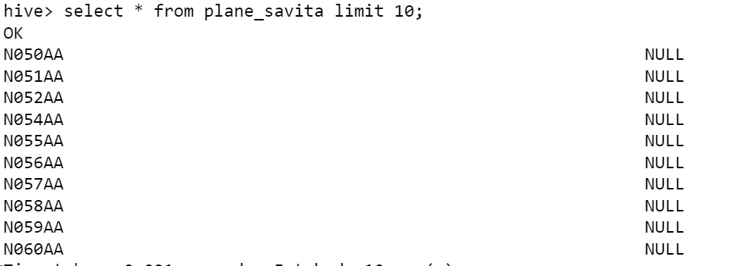

Create flights table

hive> create external table flights_savu (Year Int, Month Int, DayofMonth Int, DayOfWeek Int,DepTime Int,CRSDepTime Int,ArrTime Int, CRSArrTime Int, UniqueCarrier String, FlightNum String, TailNum String, ActualElapsedTime Int, CRSElapsedTime Int, AirTime Int, ArrDelay Int, DepDelay Int, Origin String, Dest String, Distance Int, TaxiIn String, TaxiOut String, Cancelled String, CancellationCode String, Diverted String, CarrierDelay Int, WeatherDelay Int, NASDelay Int, SecurityDelay Int, LateAircraftDelay Int) ROW FORMAT DELIMITED FIELDS TERMINATED BY ',' location '/user/mavricbdhoct07/airline/flights' TBLPROPERTIES ("skip.header.line.count"="1");

hive> load data local inpath '.csv' OVERWRITE into table flights_savu;

[mavricbdhoct07@ip-10-1-1-204 airline]$ hdfs dfs -mkdir data/airline



[mavricbdhoct07@ip-10-1-1-204 airline]$ hdfs dfs -mkdir data/airline/flights

[mavricbdhoct07@ip-10-1-1-204 airline]$ hdfs dfs -mkdir data/airline/airports

[mavricbdhoct07@ip-10-1-1-204 airline]$ hdfs dfs -mkdir data/airline/planeinfo

[mavricbdhoct07@ip-10-1-1-204 airline]$ hdfs dfs -mkdir data/airline/carrie

1.Data Setup in HDFS

Step 1: Copy the provided csv files in a directory named AirlinesOntimeAnalysis

[mavricbdhoct07@ip-10-1-1-204 ~]$ hdfs dfs -mkdir AirlinesOntimeAnalysis

Step 2: Unzip the contents for the bz2 files.

[mavricbdhoct07@ip-10-1-1-204 ~]$ cd airline [mavricbdhoct07@ip-10-1-1-204 airline]$ bzip2 -d 2003.csv.bz2

[mavricbdhoct07@ip-10-1-1-204 airline]$ bzip2 -d 2005.csv.bz2

[mavricbdhoct07@ip-10-1-1-204 airline]$ bzip2 -d 2004.csv.bz2

Step 3: Create the directories in hdfs where your data will reside

Step 4: copy the respective files to the above created hdfs

2.Create tables using Hive

hive> !hdfs dfs -ls /user/hive/warehouse/airlinedb.db;

3. Improving the performance of Hive tables - Parquet

Format

[mavricbdhoct07@ip-10-1-1-204 ~]$ ls airline

2003.csv 2004.csv 2005.csv airports.csv carriers.csv plane-data.csv

[mavricbdhoct07@ip-10-1-1-204 ~]$ hdfs dfs -put airline/2003.csv AirlinesOntimeAnalysis

[mavricbdhoct07@ip-10-1-1-204 ~]$ hdfs dfs -put airline/2004.csv AirlinesOntimeAnalysis

[mavricbdhoct07@ip-10-1-1-204 ~]$ hdfs dfs -put airline/2005.csv AirlinesOntimeAnalysis

[mavricbdhoct07@ip-10-1-1-204 ~]$ hdfs dfs -put airline/airports.csv AirlinesOntimeAnalysis

[mavricbdhoct07@ip-10-1-1-204 ~]$ hdfs dfs -put airline/carriers.csv AirlinesOntimeAnalysis

[mavricbdhoct07@ip-10-1-1-204 ~]$ hdfs dfs -put airline/plane-data.csv AirlinesOntimeAnalysis

[mavricbdhoct07@ip-10-1-1-204 ~]$ hdfs dfs -ls AirlinesOntimeAnalysis

Load the data

hive> load data inpath 'AirlinesOntimeAnalysis/airports.csv' into table airlinedb.airport_stg;

hive> load data inpath 'AirlinesOntimeAnalysis/carriers.csv' into table airlinedb.carriers_stg;

hive> load data inpath 'AirlinesOntimeAnalysis/plane_data.csv' into table airlinedb.planes_stg;

 

What is the average arrival delay and average departure delay in each month of the year 2004?

hive> select month , avg(arrdelay) as arrival_delay , avg(depdelay) as departure_delay from airlinedb.flight_stg where year=2004 group by month;

3.Improving the performance of Hive tables - Parquet format

a.Create the parquet table as external tables for flights from the above staging table.

hive> create external table flights_pq (Year Int, Month Int, DayofMonth Int, DayOfWeek Int,DepTime Int,CRSDepTime Int,ArrTime Int, CRSArrTi

me Int, UniqueCarrier String, FlightNum String, TailNum String, ActualElapsedTime Int, CRSElapsedTime Int, AirTime Int, ArrDelay Int, DepD

elay Int, Origin String, Dest String, Distance Int, TaxiIn String, TaxiOut String, Cancelled String, CancellationCode String, Diverted Stri

ng, CarrierDelay Int, WeatherDelay Int, NASDelay Int, SecurityDelay Int, LateAircraftDelay Int) STORED AS PARQUET location '/user/mavricbd

hoct07/output/airline/pq_flights';

**b.Name the new table with _pq as a suffix: Ex : flights_pq**

insert the values to flights_pq

hive> insert overwrite table flights_pq select * from flight_stg;

**Run the same query as above to check if data is loaded properly**

hive> select * from flights_pq limit 10;

OK

hive> select Month,avg(ArrDelay) as arrival_delay, avg(DepDelay) as depature_delay from flights_pq where year=2004 group by month;

**Is there a difference between the response times for the queries(2 and 3)**

Yes, both 2 and 3 query response time is difference.